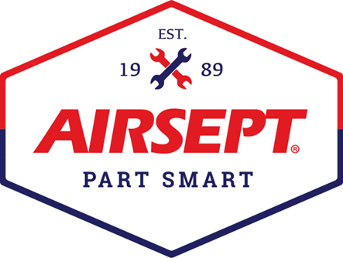

News Release

AIRSEPT INTRODUCES PROSERIES SMART SPLICE™ REPAIR KIT
AT THE 2021 SEMA SHOW FOR SPECIALTY AFTERMARKET
Complete kit to quickly and efficiently repair transmission, power steering and A/C lines on-site

Atlanta – November 2, 2021 – AirSept, a recognized leader in the traditional aftermarket for developing innovative award-winning solutions for complex automotive repair problems, is pleased to attend their first SEMA Show to introduce the company’s PROSeries Smart Splice™ line repair kits to the off-road, racing and restoration specialty aftermarket.

The PROSeries Smart Splice system is offered in two convenient kits – transmission and power steering and also air conditioning repair. Now there is a quick and durable solution for power steering and transmission line repair for all-wheel and four-wheel drive vehicles to ensure the fun doesn’t get sidetracked because of a broken transmission or power steering line. And forr racers when every second counts, race teams can now make repairs in the pits of power steering and transmission lines within minutes to be back in operation. Classic car restorers and project builders also can keep this kit handy to make repairs quickly to A/C, P/S or transmission lines to meet a show deadline or stay rolling on a cruise.

AirSept’s PROSeries Trans and P/S kit includes 16 unique repair options. The kit includes Smart Splice connectors for straight, 45˚, and 90˚ line-to-line repairs along with Smart Splice connectors for line-to-hose repair to repair almost all transmission and power steering return lines.

The Smart Splice PROSeries A/C kit includes 18 repair solutions to keep your truck or Jeep cool and comfortable regardless of the weather in hot desert conditions. Smart Splice connectors in this kit include everything needed for straight or 90˚ line-to-line repairs, straight line-to-hose, and hose-to-hose.

Smart Splice™ line repair products are superior to traditional compression fittings thanks to AIRSEPT’s proprietary sealing technology that contributes to long service life. A unique HNBR seal sleeve dramatically expands the sealing surface, and a high-tech anti-vibration tension ring ensures repair durability in heavy vibration automotive applications

The Smart Splice line repair system has been used by auto care professionals for many years to repair A/C, Transmission and Power Steering lines quickly and efficiently without the need of special tools. The Ultimate System, introduced in 2014, offers five trays of line repair solutions for air conditioning, power steering, transmission and trans oil cooler lines.

For more information on AirSept’s technician friendly and OE approved line connectors, the Smart Splice PROSeries and Ultimate product line, as well as other innovative award-winning repair solutions, visit AirSept.com, or call 678.973.2287.

# # # #
Image Attached: 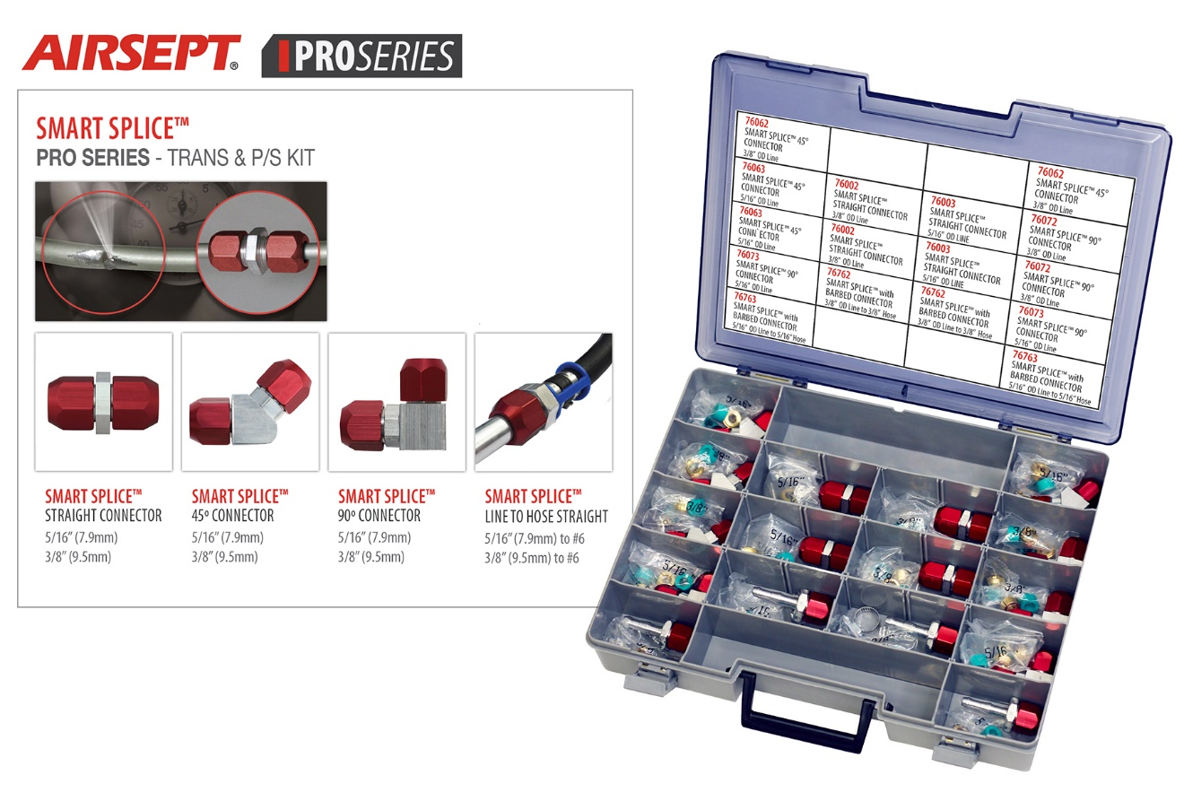

Caption: AirSept PROSeries Trans and P/S Kit

About AirSept
In 1989 AirSept created the first long-lasting solution to the problem of unwanted mold and mildew odor in automobile air conditioning systems. The product quickly became popular and in 1991 AirSept was incorporated as a company. AirSept began partnering with global OEMs and suppliers to not only market its Cooling Coil Coating, but to also develop other unique, new problem-solving products. From those humble beginnings, AirSept has grown to be the industry leader in the development of OEM and aftermarket solutions to complex automotive repair problems. AirSept products are designed to save time, money and labor. For more information, visit www.AirSept.com.

For further product information, contact:
Aaron Becker, President
AirSept
678-973-2287
abecker@airsept.com

Leslie Allen
Owner
Wildcat Communications
615-429-7965
leslieallen.wildcat@gmail.com

